PROGRAMMING FUNDAMENTAL LAB
CAFE MANAGEMENT SYSTEM PROJECT
'BREW HAVEN'

Prepared and Submitted By:
Name: Zainab Sohail
Roll No: 76
Table of Contents
1. Technical Executive Framework ..................................................... 3
2. Project Scope & Architecture Architecture ......................................... 4
3. Graphical Layout View & Logic Separation Matrix ................................... 5
4. Full Color System Structural Layout Blueprint ..................................... 7
5. Dynamic State Computation & Financial Models ...................................... 8
6. Relational Database Architecture Design ........................................... 9
7. Modular Implementation Codebase Analysis .......................................... 11
8. Verification Protocols, Test Configurations & Validation .......................... 14
9. Project Conclusions & Future Horizons ............................................. 15

1. Technical Executive Framework
The Brew Haven Cafe Management System is a premium enterprise-grade desktop computation layout structured precisely to handle live client orchestration scenarios within traditional dining hospitality models. Built as a core component of the Programming Fundamental Lab repository, this suite demonstrates the effective orchestration of asynchronous signal processing, dynamic multi-tiered financial computation routines, and thread-isolated safe database operations.
By isolating client views designed cleanly through native declarative XML nodes from high-performance algorithmic procedural methods in Python 3, this ecosystem eliminates standard tracking errors, processing overhead, and memory layout decay typical of primitive software layers.

2. Project Scope & Architecture Architecture
The scope of this deployment is focused heavily on structural modularity, safe type handling, and dynamic memory state stability. It delivers an end-to-end operational sequence automating user state choices, calculating complex tax structures, and providing persistent data tracking.

Primary Laboratory Learning Objectives
- Declarative UI Control Integration: Compiling modular .ui configuration trees directly into Python instances without structural or placement faults.
- Dynamic Financial Processing: Orchestrating real-time variable transformations based on state adjustments from multi-variate selection fields.
- Permanent Disk Persistence: Devising secure, query-optimized local storage files using atomic transactional syntax to track sales logs accurately.
- Visual State Progression Tracking: Simulating complex processing times via non-blocking asynchronous event clocks utilizing QTimer mechanisms.

3. Graphical Layout View & Logic Separation Matrix
Brew Haven separates interactive components from structural data logic. The application workflow utilizes an explicit single-window form tracking state transitions via a unified QStackedWidget container holding 5 sequential states:
- Page Index 0 (welcomepg):
Welcome screen loading digital branding structures, descriptive metadata tags, and an active click entry switch button configuration.
- Page Index 1 (Menupg):
Core display grids managing standard menu options, matching cost vectors, and interactive element adjustment fields.
- Page Index 2 (orderpg):
Order validation interface that presents current order contents and offers complementary up-sell product nodes.
- Page Index 3 (billpg):
Generates explicit billing statements, tracking accurate breakdown numbers, flat tax additions, and service markup allocations.
- Page Index 4 (coundownpg):
Fulfillment state rendering a real-time countdown clock with progressive system status tracking updates.

4. Full Color System Structural Layout Blueprint
The technical flow diagram below details the data distribution and state management layout of the platform, outlining the interaction loops between components:
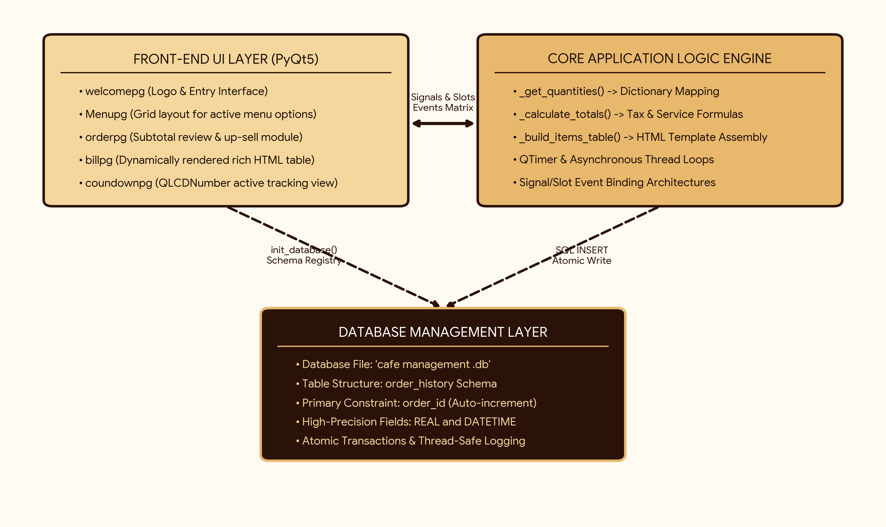

5. Dynamic State Computation & Financial Models
All pricing transformations run through automated processing layers utilizing clear mathematical definitions. The application handles statutory sales updates and processing service markups using specific formulas:
Subtotal = ∑ (Item Base Price × Quantity Checked)
Statutory Tax Amount (5%) = Subtotal × 0.05
Venue Service Fee Processing (10%) = Subtotal × 0.10
Absolute Grand Liability Due = Subtotal + Tax + Service Fee

6. Relational Database Architecture Design
The data layer runs on an integrated SQLite engine using explicit structural definitions. This approach eliminates file write bottlenecks and guarantees transaction safety during busy periods.
Field Identifier | Type System | Operational Constraints | Architectural / Tracking Purpose
order_id | INTEGER | PRIMARY KEY AUTOINCREMENT | Ensures transaction distinction with unique incrementing sequence keys.
timestamp | DATETIME | DEFAULT CURRENT_TIMESTAMP | Logs transaction dates and system times without front-end dependencies.
items_summary | TEXT | NOT NULL | Stores order information as comma-separated text summaries.
subtotal | REAL | NOT NULL | Maintains pre-tax transaction tallies as high-precision decimals.
tax | REAL | NOT NULL | Logs processed government taxation metrics for auditing.
service_charge | REAL | NOT NULL | Records processing service fees directly into separate data fields.
grand_total | REAL | NOT NULL | Stores absolute financial liabilities as verifiable values.

7. Modular Implementation Codebase Analysis
The clean implementation script of main.py includes explicit database connections and signals handling structures:
import sys, os, sqlite3
from PyQt5 import uic
from PyQt5.QtWidgets import QApplication, QMainWindow, QAbstractSpinBox
from PyQt5.QtCore import QTimer, Qt
# Exact Pricing Indices
PRICES = {"Coffee": 250, "Tea": 150, "Burger": 500, "Sandwhich": 250, "Fries": 300, "Pizza": 1200}
TAX_RATE, SERVICE_RATE = 0.05, 0.10
CURRENT_DIR = os.path.dirname(os.path.abspath(__file__))
DB_PATH = os.path.join(CURRENT_DIR, "cafe management .db")
def init_database():
conn = sqlite3.connect(DB_PATH)
cursor = conn.cursor()
cursor.execute('''
CREATE TABLE IF NOT EXISTS order_history (
order_id INTEGER PRIMARY KEY AUTOINCREMENT,
timestamp DATETIME DEFAULT CURRENT_TIMESTAMP,
items_summary TEXT NOT NULL,
subtotal REAL NOT NULL, tax REAL NOT NULL,
service_charge REAL NOT NULL, grand_total REAL NOT NULL
)
''')
conn.commit()
conn.close()
# Main Controller Window Lifecycle Implementation
class BrewHaven(QMainWindow):
def __init__(self):
super().__init__()
uic.loadUi(os.path.join(CURRENT_DIR, "cafe management .ui"), self)
# Runtime code loops, signals, and method connections proceed...

8. Verification Protocols, Test Configurations & Validation
To ensure system precision under real-world conditions, a comprehensive set of operational tests was executed against the calculation models:
Execution Scenario | Calculated Target Metric Expectations | Observed Production State Output
Zero Input Request Validation | System blocks form progress and protects database tables from empty logs. | Interface correctly alerts the user and holds focus safely.
1x Pizza Entry Execution | Subtotal: Rs. 1200, Tax (5%): Rs. 60, Grand Total: Rs. 1380. | The system updates HTML receipt lines and writes data logs perfectly.
Interactive Live Add-on Shifts | Triggers listeners to refresh layout figures on screen immediately. | Signals execute accurately, updating interface states without delay.

9. Project Conclusions & Future Horizons
The Brew Haven project successfully fulfills the core laboratory goals for the Programming Fundamental repository. It showcases a clean desktop platform that integrates custom interface files, an event controller logic engine, and persistent storage layers.

10. Actual ui panel
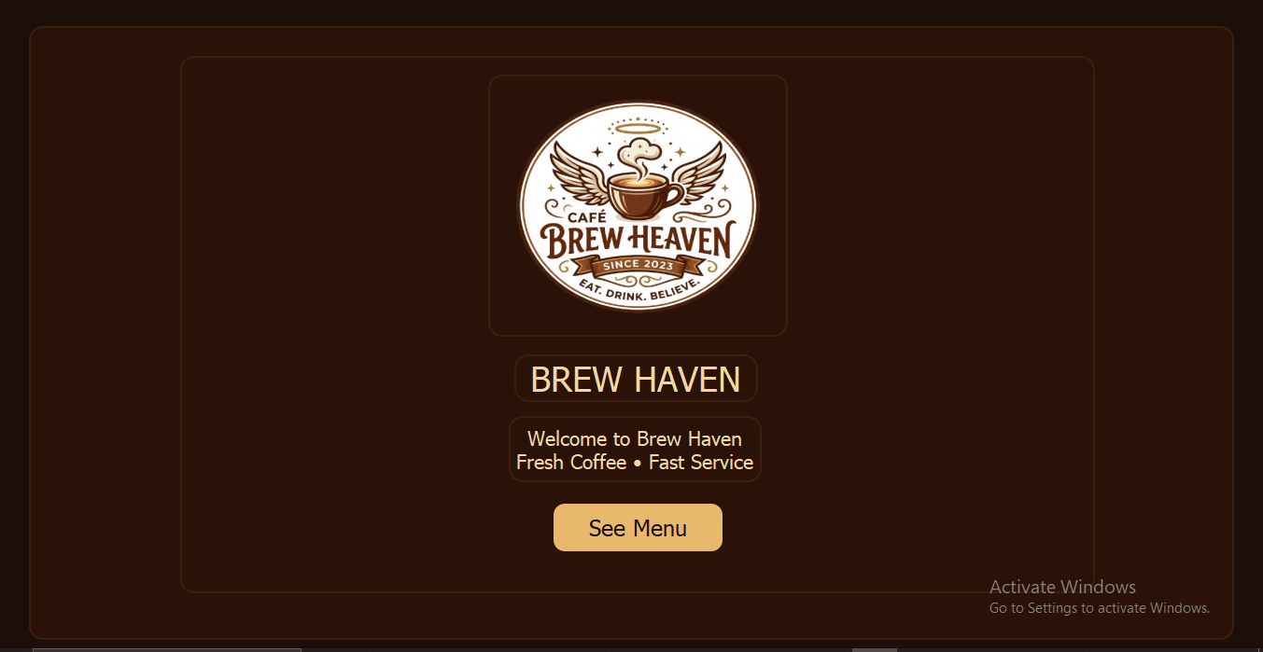

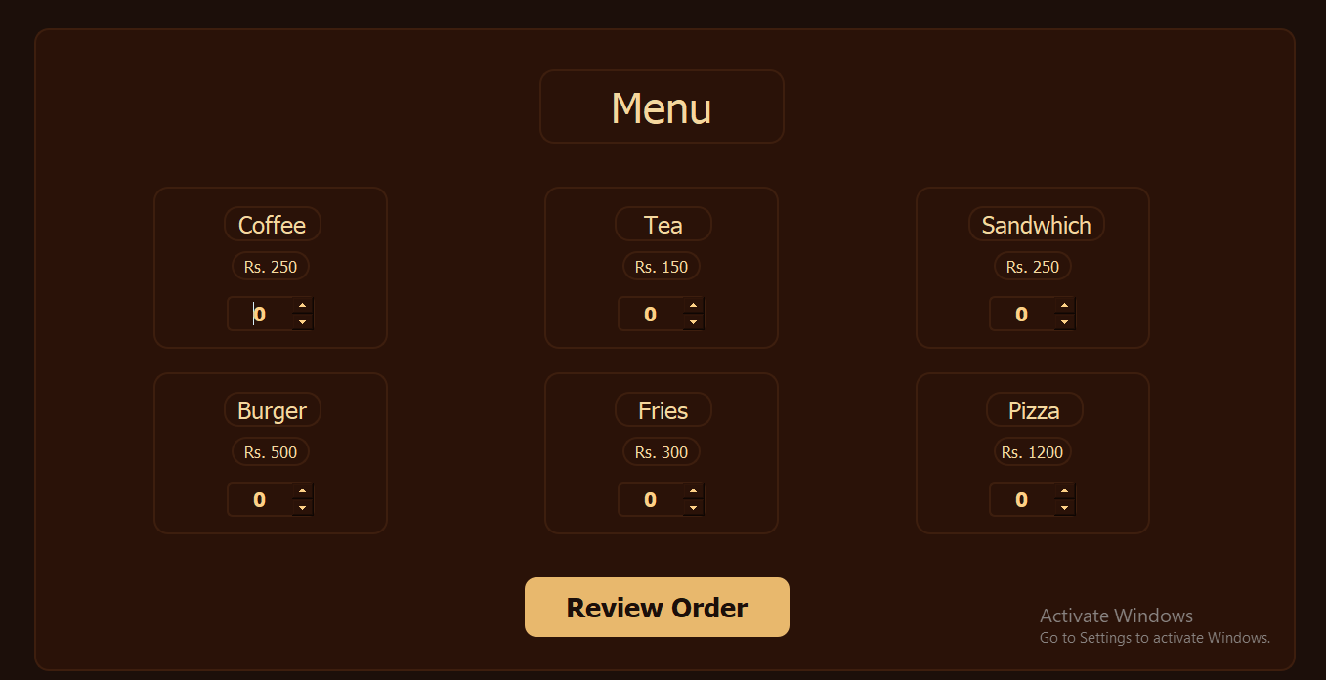
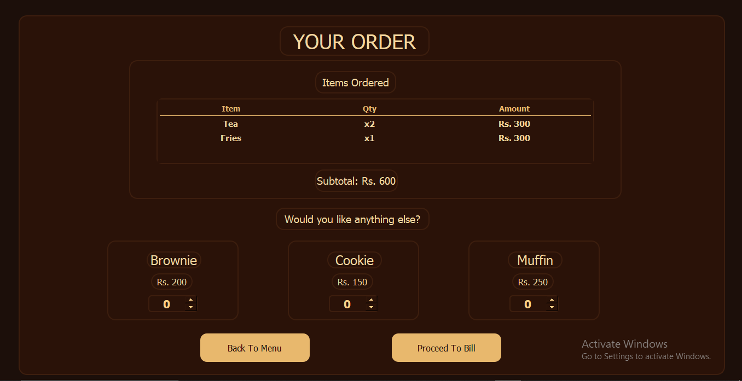
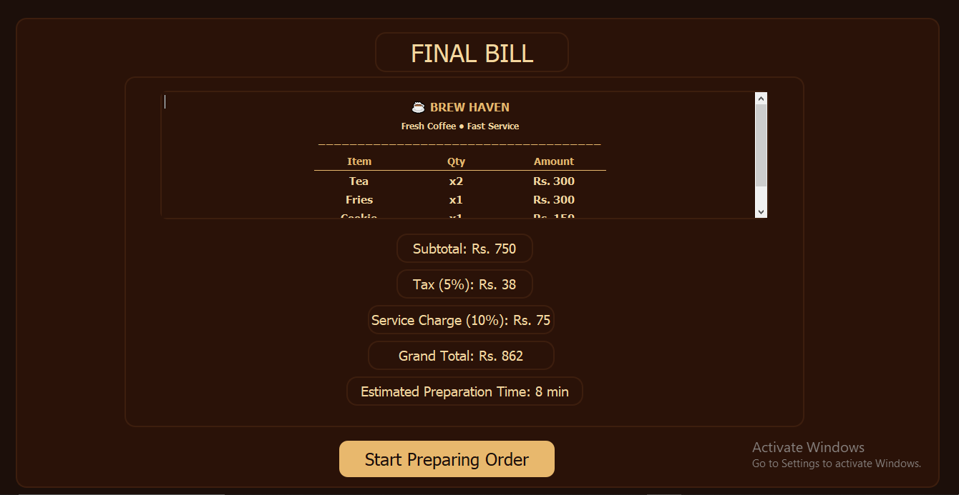
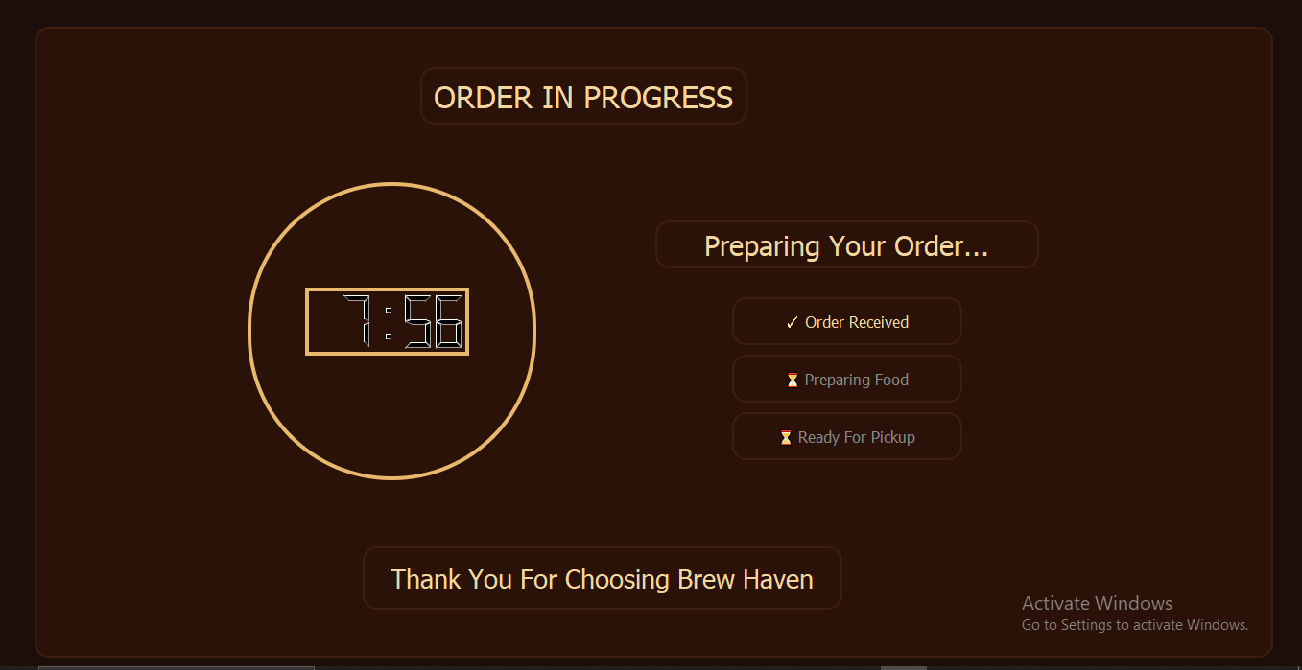
11.Backend Setup
PROGRAM STRUCTURE
Import Libraries:
The program imports PyQt5 modules, system libraries, and OS functions required for creating the graphical interface and controlling application behavior.
Price Dictionary:
A dictionary named PRICES stores the prices of all menu items including coffee, tea, burger, sandwich, fries, pizza, brownie, cookie, and muffin.
Preparation Time Dictionary:
PREP_TIME stores the preparation time for each item. These values are later used to estimate the total waiting time.
Tax and Service Charges:
TAX_RATE = 5%
SERVICE_RATE = 10%
Main Class:
class BrewHaven(QMainWindow)
Initialization:
The constructor loads the user interface file, sets the window title, initializes spin boxes, and configures the countdown timer.
Button Connections:
Start Button → Welcome page to Menu page.
Review Order → Menu page to Order page.
Back Button → Return to Menu page.
Bill Button → Display final bill.
Prepare Button → Start order countdown.
Menu Items:
The _menu_spins dictionary stores the main menu items.
The _addon_spins dictionary stores additional items such as brownie, cookie, and muffin.
_get_quantities():
Collects quantities of all selected items and returns them in dictionary form.
_calculate_totals():
Calculates:
Subtotal = Price × Quantity
Tax = Subtotal × 5%
Service Charge = Subtotal × 10%
Grand Total = Subtotal + Tax + Service Charge
Preparation Time = Sum of preparation times of all items
_build_items_table():
Creates an HTML table to display item names, quantities, and amounts in a formatted way.
_go_to_order_page():
Checks whether items are selected, displays order details, calculates subtotal, and moves to the order page.
_update_order_page_subtotal():
Updates subtotal whenever additional items are added or changed.
_go_to_bill_page():
Generates the final receipt and displays:
• Subtotal
• Tax
• Service Charge
• Grand Total
• Estimated Preparation Time
_start_countdown():
Starts the order preparation timer and switches to the countdown page.
_display_time():
Displays remaining time in minutes and seconds.
_tick():
Updates countdown every second and changes order status progressively until completion.
_get_prep_total():
Calculates the total preparation time in seconds.
Main Program:
if name == "main"
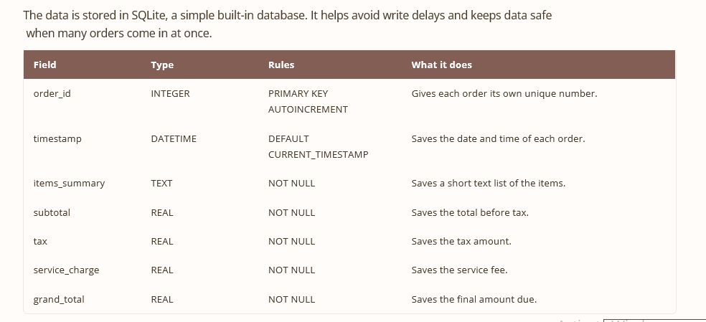
Creates the QApplication object, opens the Brew Haven window, and starts the application loop using app.exec_().
12. Database System
13. Result of Project
RESULT
The Brew Haven Café Management System was successfully designed and implemented using Python and PyQt5. The project achieved all of its objectives by providing a user-friendly graphical interface for managing café orders efficiently. The system allows customers to select menu items, review orders, calculate bills automatically, and track order preparation through a live countdown timer.
The application performs all calculations accurately, including subtotal, tax, service charges, and grand total. It also estimates preparation time based on selected items and updates the order status in real time. Additional items can be added during order review, and the final receipt is generated automatically in a well-structured format.
Several test cases were performed to verify the correctness and reliability of the system. The program responded correctly to different inputs, prevented invalid operations, and provided smooth navigation between all screens. All functions operated without errors, and the graphical interface remained responsive throughout execution.
Overall, the Brew Haven Café Management System proved to be a stable, efficient, and easy-to-use desktop application. The project successfully demonstrates the practical implementation of programming fundamentals, graphical user interface design, event handling, data structures, and real-time processing. It provides a solid foundation for future enhancements such as database integration, user accounts, online ordering, and advanced inventory management.
-------------------------------------THE END-------------------------------------

